**Insert data in MYSQL using Python [Tkinter Library]**

Create Registration form and store data in MySQL Database.

Hello friends how are you, today in this blog i will teach you how you can insert data into MySQL Database using Python and Tkinter GUI Library. This tutorial will help you definitely if you wan to create a window application in Python or if you want to make any kind of projects or Software Applications. I am using PyCharm IDE and now i am going to describe everything step by step so just go through this post to get complete knowledge.

Registration form is one of the most used Form in Window or GUI Applications, It helps user to Register by using  name, contact, email, etc actually it depends upon the type of Registration.

Here in this post i am using name, contact, email, gender, city and state of user for Registration.

Here i have created a Registration form using Tkinter GUI library in which i have used name, contact, email, gender, city and state of user for Registration.

Now go through  this post step by step to learn completely.

Create a Database

Open your MySQL and create a Database "PythonData" if you want to create using query then copy the code below ,following is the query of creating database in MySQL

CREATE DATABASE PythonData

Create a Table

Now create a Table[REG] inside  Database[PythonData], following is the query to create a table in MySQL database

CREATE TABLE REG (

RID int NOT NULL AUTO_INCREMENT,

NAME varchar(255) NOT NULL,

CONTACT varchar(255),

EMAIL varchar(255),

GENDER varchar(255),

CITY varchar(255),

STATE varchar(255),

PRIMARY KEY (RID)

);

After doing these we have a database and a Table without any data like below

[https://1.bp.blogspot.com/-oSkJ1n-wzvU/X7izH18fsbI/AAAAAAAABpI/_Glz9W6qF2Qq5be0Y4QrryR_mXHST6PYwCLcBGAsYHQ/s320/mysql%2Breg.png](https://1.bp.blogspot.com/-oSkJ1n-wzvU/X7izH18fsbI/AAAAAAAABpI/_Glz9W6qF2Qq5be0Y4QrryR_mXHST6PYwCLcBGAsYHQ/s492/mysql+reg.png)

Syntax of Inserting data into table

Following is the syntax of inserting data into table

INSERT INTO TABLE_NAME (column1, column2,column3,...columnN)

VALUES (value1, value2, value3,...valueN);

Install mysql.connector Package or Library

If you want to manipulate data in MySQL using Python then this library is compulsory without this library python can't communicate with MySQL.

If you write and execute your code in command prompt or Python IDLE then write the below code in command prompt to install this library

pip install mysql-connector

below is the screenshot of command prompt

[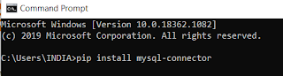](https://1.bp.blogspot.com/-oxDSEe9RwB4/X7i30p3mfLI/AAAAAAAABpk/-fBCdvnC8B0Rxxj4lqh_gjhGna3SoooSgCLcBGAsYHQ/s508/mysql+cmd.png)

But i will suggest all of you to use Pycharm IDE for python because according to me it is the best IDE for Python.Now i am going to tell you how you can install this library using Pycharm

To install go to File and click on Setting

[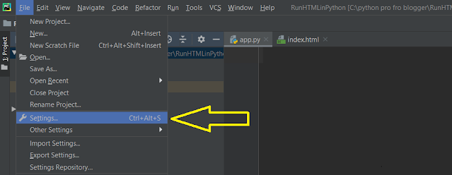](https://1.bp.blogspot.com/-MK85B9Ez_HI/X7OBvBSAp0I/AAAAAAAABh0/mm075k9s_9s6vytvex52tppMaf4qREEhwCLcBGAsYHQ/s999/file+set.png)

After clicking on Setting you will get a screen like below

[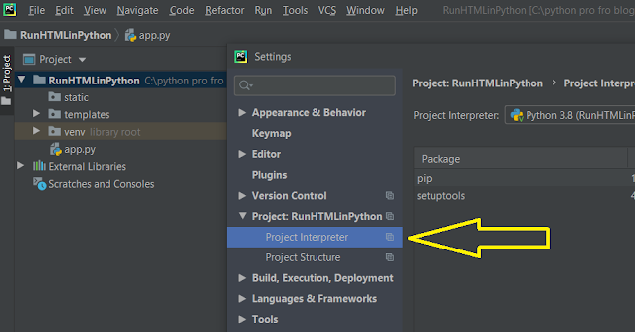](https://1.bp.blogspot.com/-X-W1FeRGFAc/X7OCM56X4GI/AAAAAAAABh8/wxrAxRgfQLYvKezdwFAURPCtcTAl9tDVgCLcBGAsYHQ/s921/inter.png)

Here in above screen you have to click on Project Interpreter and after clicking you will get a screen like below

[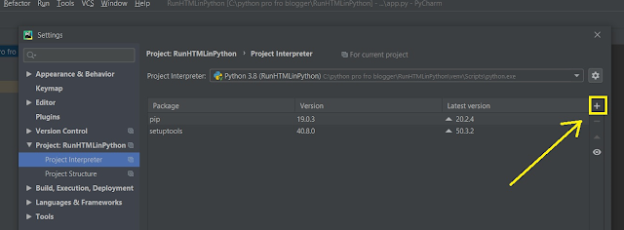](https://1.bp.blogspot.com/-41k8NMnJFGs/X7OC6hvo12I/AAAAAAAABiI/AtFeBrSyZeEa7c2ofuzYK_VR6GfCSP6twCLcBGAsYHQ/s1314/pls2.png)

Here in above screen you have to click on plus[+] icon as indicated by arrow, after clicking on it you will get a screen like below

[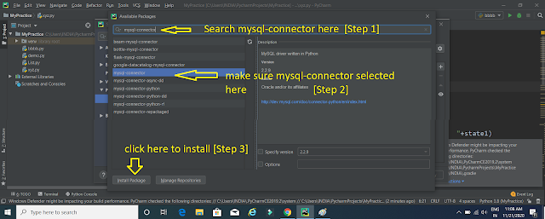](https://1.bp.blogspot.com/-4O9AGDG__Qc/X7i7CBOY_mI/AAAAAAAABqA/ER27zFd3Ht0fRso10xI1jmBoskfbrWhvACLcBGAsYHQ/s1920/mysql+connect.png)

here in above screen first search "mysql-connector" in search box then make sure "mysql-connector" is selected as indicated above and finally click on "Install Package" to add this library in your project, after that wait for some seconds [It depends upon your internet speed] it will display a message below.

[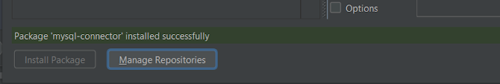](https://1.bp.blogspot.com/-Kj_CkjELGm0/X7i7anESn7I/AAAAAAAABqI/KHeK8NhspYcVFujyAALy80EmGRR9JRHbgCLcBGAsYHQ/s810/mysql+success.png)

Write Python Code

Here is the complete code for inserting data in MySQL using Python just copy and paste into your editor

from tkinter import *

from tkinter import ttk

#importing connection

import mysql.connector

#establishing connection

conn = mysql.connector.connect(

user='root', password='', host='localhost', database='pythondata')

"""

here in my case there is no password so password='' is blank

root is username

localhost is server or host name

you can also use 127.0.0.1 in place of local host

pythondata is the name of Database

"""

#defining register function

def register():

#getting form data

name1=name.get()

con1=contact.get()

email1=email.get()

gen1=gender.get()

city1=city.get()

state1=state.get()

#applying empty validation

if name1=='' or con1==''or email1=='' or gen1==''or city1==''or state1=='':

message.set("fill the empty field!!!")

else:

# Creating a cursor object using the cursor() method

cursor = conn.cursor()

# Preparing SQL query to INSERT a record into the database.

insert_stmt = (

"INSERT INTO REG(NAME, CONTACT, EMAIL, GENDER, CITY, STATE)"

"VALUES (%s, %s, %s, %s, %s, %s)"

)

if gen1==1:

data = (name1, con1,email1,"Male",city1,state1)

else:

data = (name1, con1, email1, "Female", city1, state1)

try:

#executing the sql command

cursor.execute(insert_stmt,data)

#commit changes in database

conn.commit()

except:

conn.rollback()

message.set("Stored successfully")

#defining Registrationform function

def Registrationform():

global reg_screen

reg_screen = Tk()

#Setting title of screen

reg_screen.title("Registration Form")

#setting height and width of screen

reg_screen.geometry("350x400")

#declaring variable

global message;

global name

global contact

global email

global gender

global city

global state

name = StringVar()

contact = StringVar()

email=StringVar()

gender=IntVar()

city=StringVar()

state=StringVar()

message=StringVar()

#Creating layout of Registration form

Label(reg_screen,width="300", text="Please enter details below", bg="orange",fg="white").pack()

#name Label

Label(reg_screen, text="Name * ").place(x=20,y=40)

#name textbox

Entry(reg_screen, textvariable=name).place(x=90,y=42)

#contact Label

Label(reg_screen, text="Contact * ").place(x=20,y=80)

#contact textbox

Entry(reg_screen, textvariable=contact).place(x=90,y=82)

# email Label

Label(reg_screen, text="Email * ").place(x=20, y=120)

# email textbox

Entry(reg_screen, textvariable=email).place(x=90, y=122)

# gender Label

Label(reg_screen, text="Gender * ").place(x=20, y=160)

# gender radiobutton

Radiobutton(reg_screen,text="Male",variable=gender,value=1).place(x=90,y=162)

Radiobutton(reg_screen, text="Female", variable=gender, value=2).place(x=150, y=162)

# city Label

Label(reg_screen, text="City * ").place(x=20, y=200)

# city combobox

monthchoosen = ttk.Combobox(reg_screen, width=27, textvariable=city)

monthchoosen['values'] = (' Mumbai',

' Bhopal',

' Patna',

' Indore',

' Nagpur',

' Motihari',

' Pune',

' Gwalior',

' Jabalpur',)

monthchoosen.current()

monthchoosen.place(x=90,y=202)

# state Label

Label(reg_screen, text="State * ").place(x=20, y=240)

# state combobox

monthchoosen = ttk.Combobox(reg_screen, width=27, textvariable=state)

monthchoosen['values'] = (' Madhya Pradesh',

' Maharashtra',

' Bihar',

' Punjab',

' Gujrat',

' Rajsthan',)

monthchoosen.current()

monthchoosen.place(x=90, y=242)

#Label for displaying login status[success/failed]

Label(reg_screen, text="",textvariable=message).place(x=95,y=264)

#Login button

Button(reg_screen, text="Register", width=10, height=1, bg="orange",command=register).place(x=105,y=300)

reg_screen.mainloop()

#calling function Registrationform

Registrationform()

when you run the code you will get screen like below

[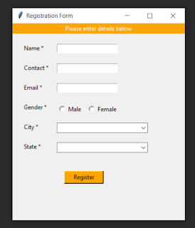](https://1.bp.blogspot.com/-KtXvwnvzm5s/X7XxqjSYcNI/AAAAAAAABmg/MO0-heK1vtgMrsHqvQA9aZvNlmNcQsFSACLcBGAsYHQ/s579/reg+screen.png)

Registration Form with empty validation

I have applied a Empty Validation means if you left blank any field then you will get a message "fill the empty field!!!" after pressing button.

[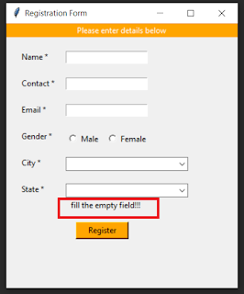](https://1.bp.blogspot.com/-UftkBs7oa6c/X7XydtUlmkI/AAAAAAAABms/J68SH2S5sa8rLdzAvXE5QqDn6Db67ADsQCLcBGAsYHQ/s555/reg+empty.png)

Registration Form with stored successfully

When you will fill all the fields and click on Register button then form data will be stored in Table[Reg] in Database[PythonData].

[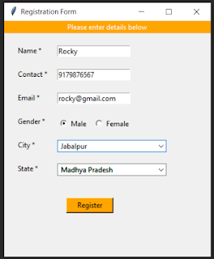](https://1.bp.blogspot.com/-UDrF-5lHNWE/X7X08eBs3HI/AAAAAAAABnI/oXiqqM-3OPs7aZVv4umT1r77nre_SCybgCLcBGAsYHQ/s549/reg+data.png)

When you click on Register button you will get a message "Stored Successfully" and data will be stored in MySQL Database.

[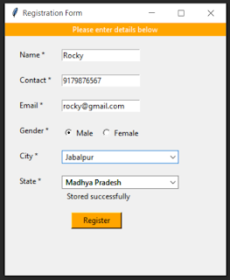](https://1.bp.blogspot.com/-Du8myLKauEk/X7X1f4KF4JI/AAAAAAAABnQ/iJ-YtQEtEdkPpRzYasUJ-Z79bfF3CYQhgCLcBGAsYHQ/s554/reg+success.png)

Registration Students Record

Here i am providing the screenshot of file where all the records of registered students are present.

[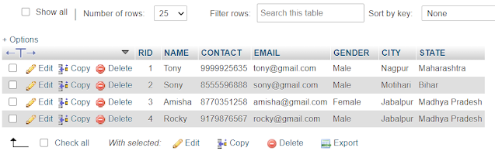](https://1.bp.blogspot.com/-OiQahn1EUbI/X7i-7UeVYTI/AAAAAAAABqk/RqShDlxC28suKlbJHq3cO36zmHR1Z1kOwCLcBGAsYHQ/s965/mysql+data.png)

Widgets used to create Registration Form

1.Label  
2.TextBox or EditText(Entry)  
3.Radiobutton  
4.Combobox  
5.Button